**Laboratory Four**



**Javier Jesús Macossay-Hernández**

**EE348L – Electronic Circuits**

**University of Southern California**

**Professor Susan Schober**

**Introduction**

In this laboratory, implementation of hand analysis and HSPICE simulations were done to understand the behavior of diodes. Furthermore, the circuits were built in class and different tests were done to them to corroborate our hand calculations and simulation results.

Exercise 1

**Procedure**

On Exercise 1, a circuit with a resistor and a diode in series was built. A 1 kΩ was used to measure the current, then it was replaced by a 10 kΩ resistor.

**Data**

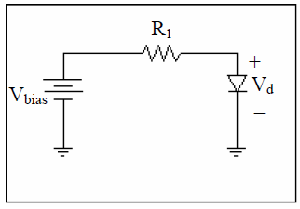

Schematic of the circuit

**Questions**

The current while using the 1 kΩ resistor is 0.46 mA and the diode voltage is 0.536 V. The current while using the 10 kΩ resistor is 0.056 mA and the diode voltage is 0.439 V. The relative change in current decreases by a multiplicative factor (it gets divided by) 8.21 and the diode voltage decreases by a factor of 1.22.

**Discussion**

The results agree with the estimate in the pre-laboratory exercises because the diode voltage and the current decrease when the resistance value is augmented.

Exercise 2

**Procedure**

On Exercise 2, the same circuit was built, but the resistor was replaced by a potentiometer. The resistance was varied from 1 kΩ to 10 kΩ, later from 10 kΩ to 100 kΩ, while the current and diode voltage were being monitored.

**Data**

Table with Values using the Potentiometer from 1 kΩ to 10 kΩ

|  |  |  |  |
| --- | --- | --- | --- |
| **1 k to 10 k** | **Resistance Value ()** | **VR (Resistor Voltage Drop)** | **IR (Current)** |
| **1** | 1.21 | 0.473 | 0.391 |
| **2** | 2.42 | 0.504 | 0.208 |
| **3** | 3.474 | 0.521 | 0.150 |
| **4** | 3.856 | 0.525 | 0.136 |
| **5** | 4.721 | 0.533 | 0.113 |
| **6** | 6.059 | 0.543 | 0.090 |
| **7** | 7.494 | 0.552 | 0.074 |
| **8** | 8.584 | 0.558 | 0.065 |
| **9** | 8.975 | 0.56 | 0.062 |
| **10** | 10.229 | 0.565 | 0.055 |

Table with Values using the Potentiometer from 10 kΩ to 100 kΩ

|  |  |  |  |
| --- | --- | --- | --- |
| **10 k to 100 k** | **Resistance Value ()** | **VR (Resistor Voltage Drop)** | **IR (Current)** |
| **1** | 11.21 | 0.583 | 0.052 |
| **2** | 19.61 | 0.59 | 0.030 |
| **3** | 28.14 | 0.603 | 0.021 |
| **4** | 39.63 | 0.616 | 0.016 |
| **5** | 48.75 | 0.624 | 0.013 |
| **6** | 60.53 | 0.632 | 0.010 |
| **7** | 68.08 | 0.636 | 0.009 |
| **8** | 80.87 | 0.642 | 0.008 |
| **9** | 89.87 | 0.646 | 0.007 |
| **10** | 96.49 | 0.649 | 0.007 |

I-V characteristics using the Potentiometer from 1 kΩ to 10 kΩ

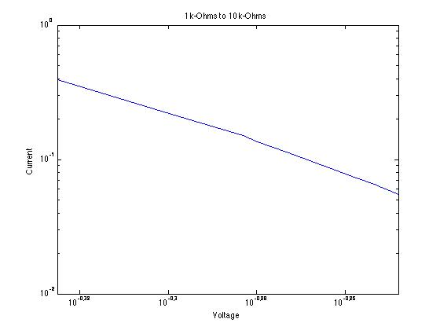

I-V characteristics using the Potentiometer from 10 kΩ to 100 kΩ

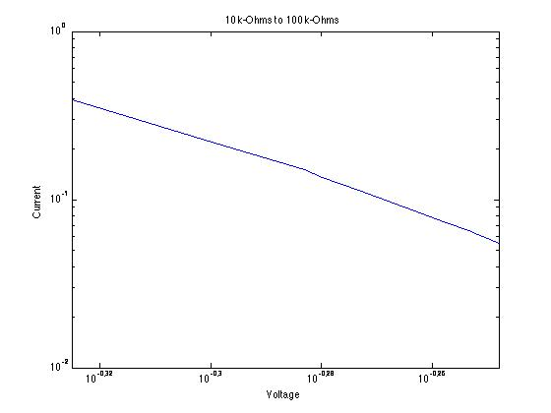

**Questions**

No questions were asked in this exercise.

**Discussion**

The current and the diode voltage decreased as expected when the resistance value incremented and meeting expectations of the results from Exercise 1.

Exercise 3

**Procedure.**

On Exercise 3, a circuit with two voltage, AC and DC, sources was built using a 10 kΩ and a diode. Later, the time constant was measured while using different Vbias, DC voltage. The values of Vbias were 0.2 V, 0.4 V, -0.2 V, and -0.4 V. Finally, the capacitance of the diode was calculated using the known value of the resistance for each Vbias.

**Data**

|  |  |  |  |
| --- | --- | --- | --- |
| Vbias (V) | - 3dB Frequency (Hz) | Vo (mV) | C |
| 0.3 | 300 kHz | 212 | 53 pF |
| 0.5 | 230 kHz | 203 | 69 pF |
| -0.3 | 390 kHz | 217 | 44.2 nF |
| -0.5 | 390 kHz | 217 | 44.2 nF |

**Questions**

According to the results obtained from the laboratory experiment, the capacitance of a diode changes with respect to the bias voltage. The capacitance increase with increasing forward bias and it decreases, but at some point it remains constant, in reverse bias. If the capacitance of the diode is greater than 44.2 nF without applying a voltage bias, then it decreases with reverse bias. The capacitance changes more drastically with forward bias, according to the experimental results.

**Discussion**

The data, showed in the Data section, matches with the hand calculations, which states that the capacitance increases as Vbias increases, the capacitance is inversely proportional to the reverse bias, and the capacitance changes more drastically under forward bias condition. Therefore, the results agree with the analysis from the pre-laboratory where the same facts were concluded.

Exercise 4

**Procedure**

On Exercise 4, four different configurations of the circuit were built. In two of them a Vbias, DC, and an AC source were applied and in the other two circuits only an AC source was applied.

**Data**

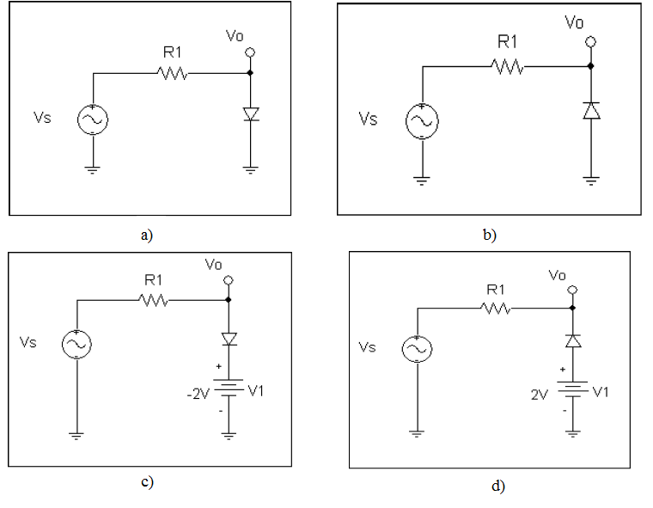

**Figure 4-14:** (a), (b), (c) and (d) for pre-lab exercise 3. R1 = 1 KΩ. The signal source has a frequency of 5 kHz and amplitude of 3V.

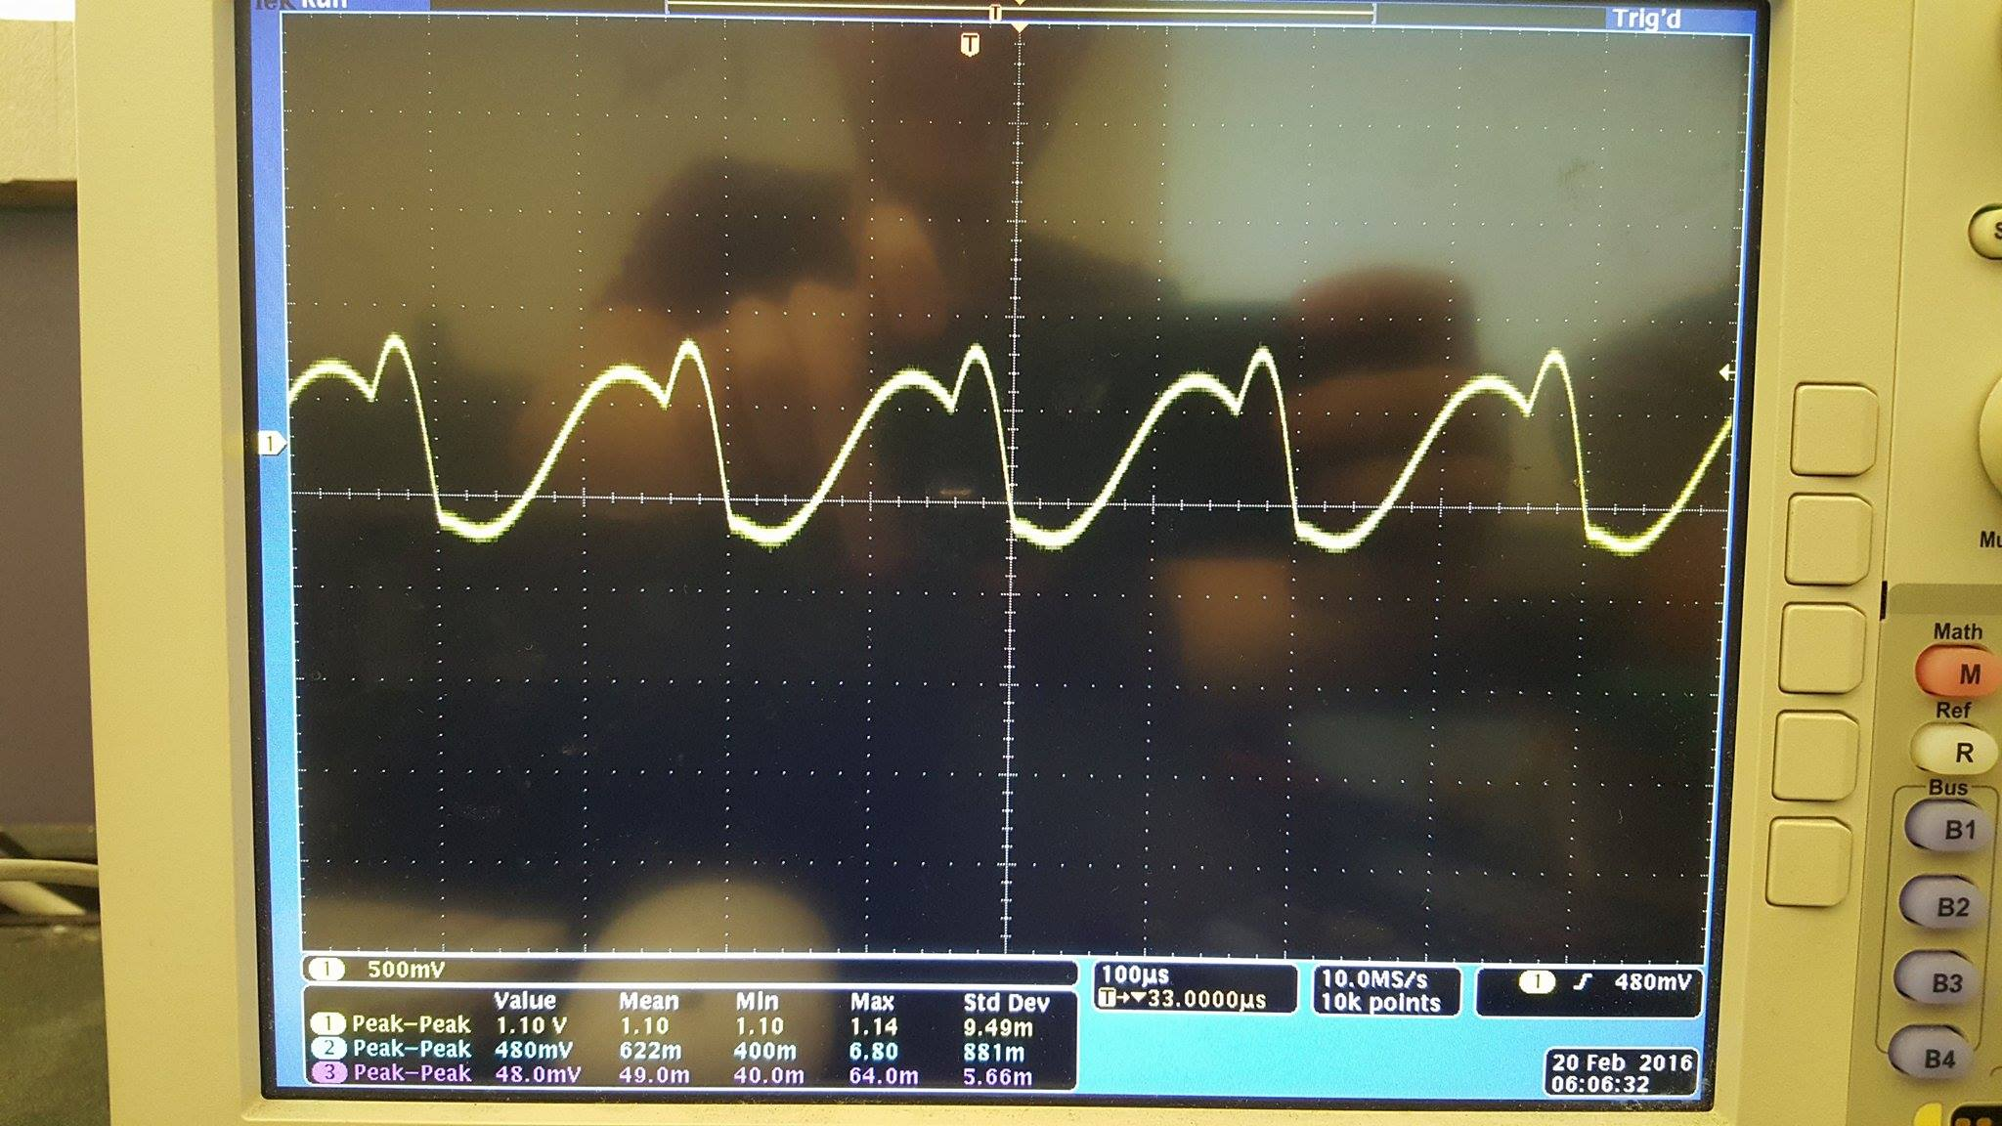

Voltage across Resistor for Circuit A

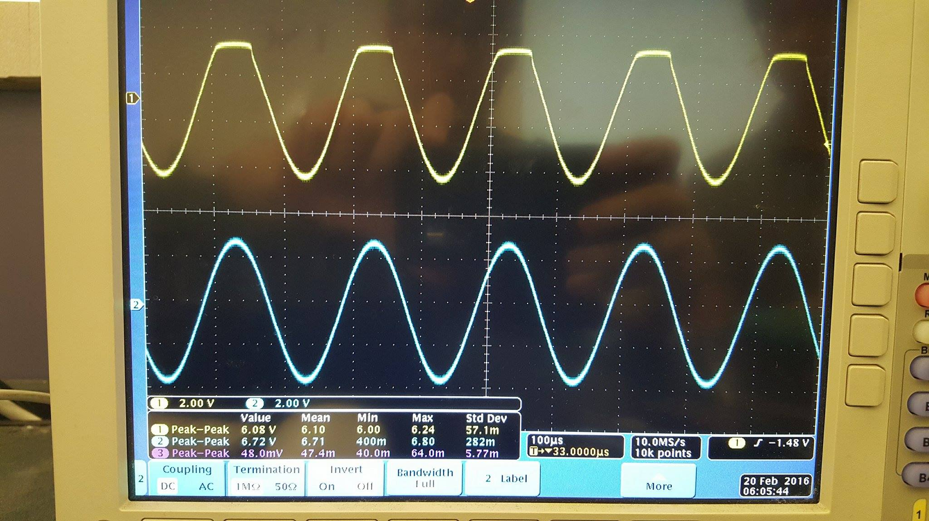

Voltage Input and Voltage Output for Circuit A

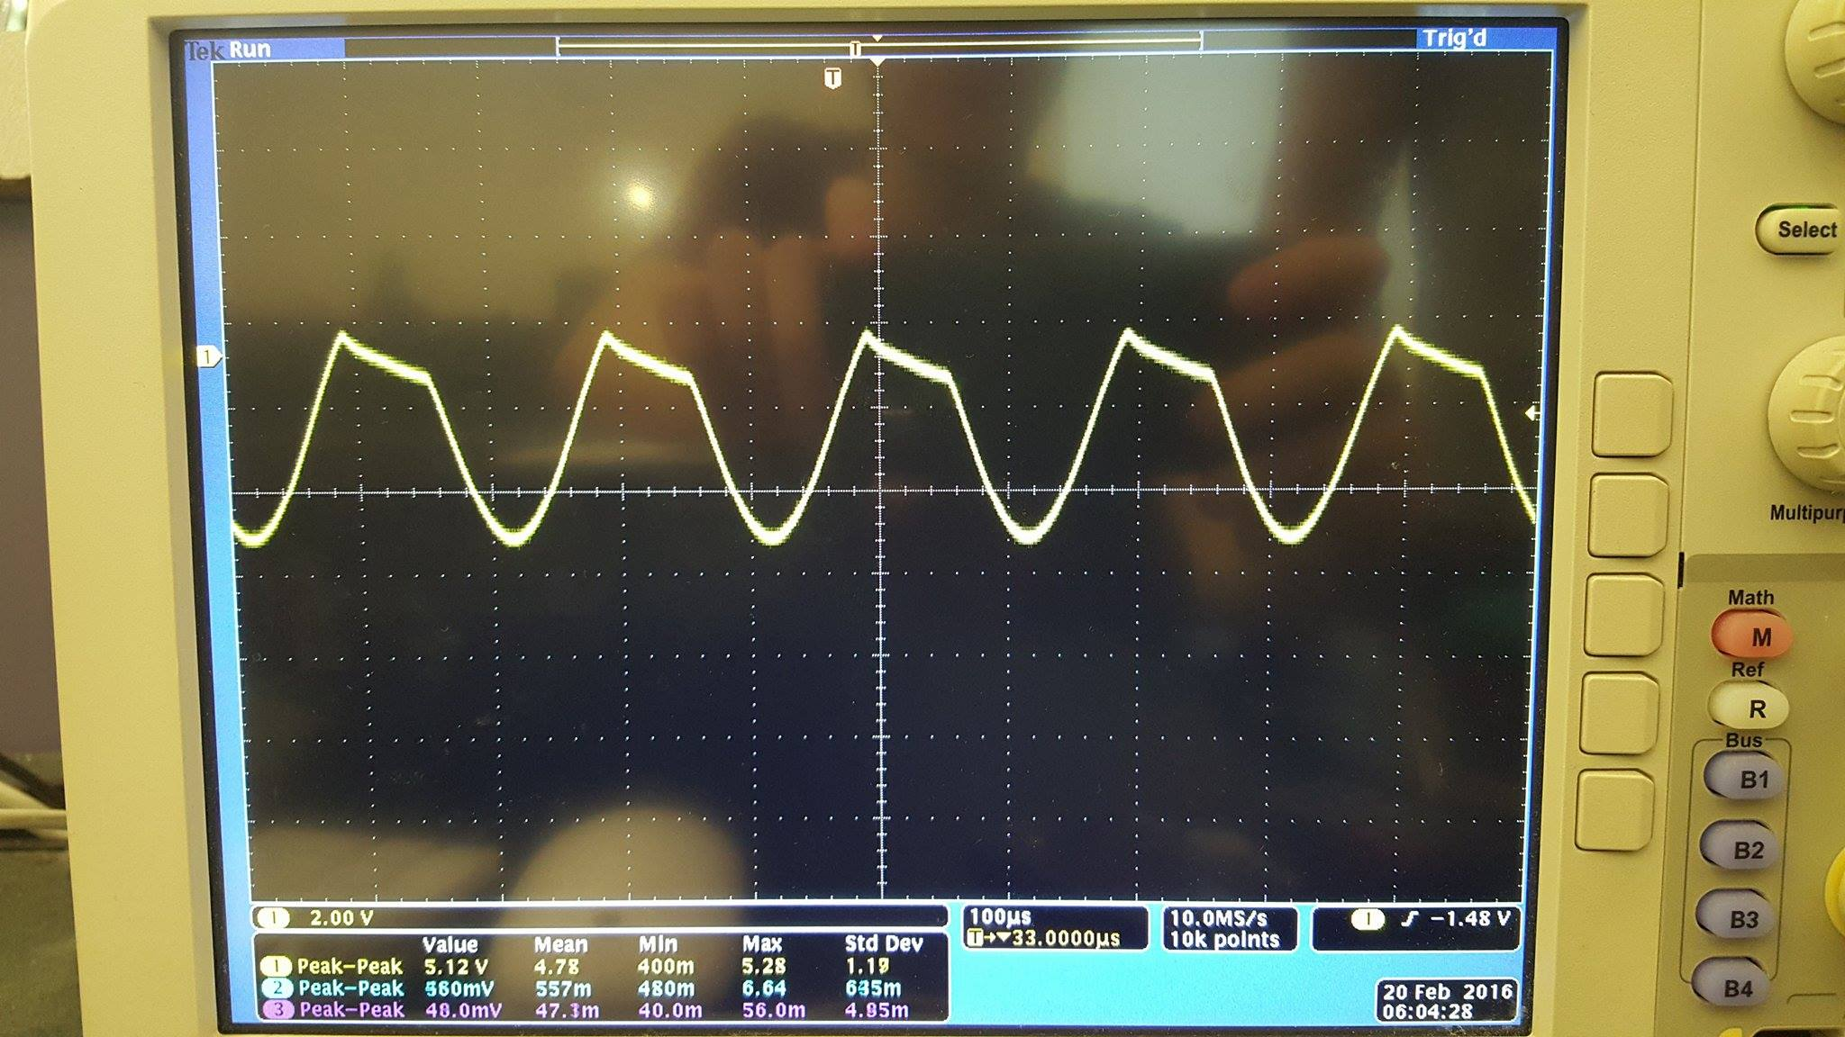

Voltage across Resistor for Circuit B

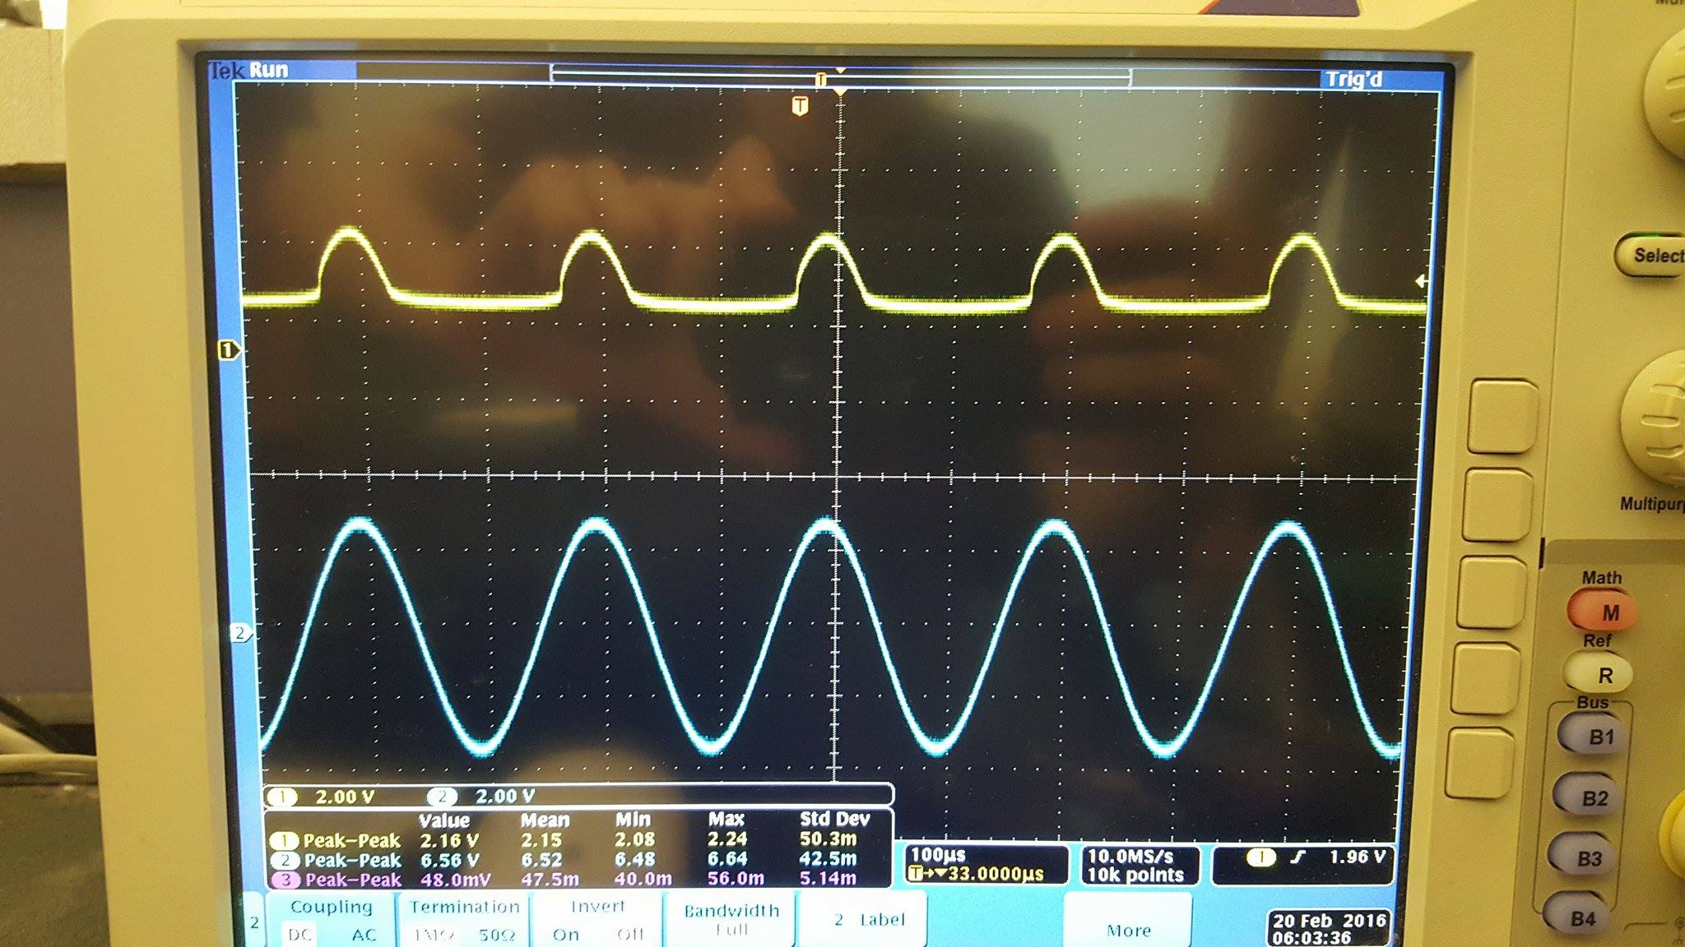

Voltage Input and Voltage Output for Circuit B

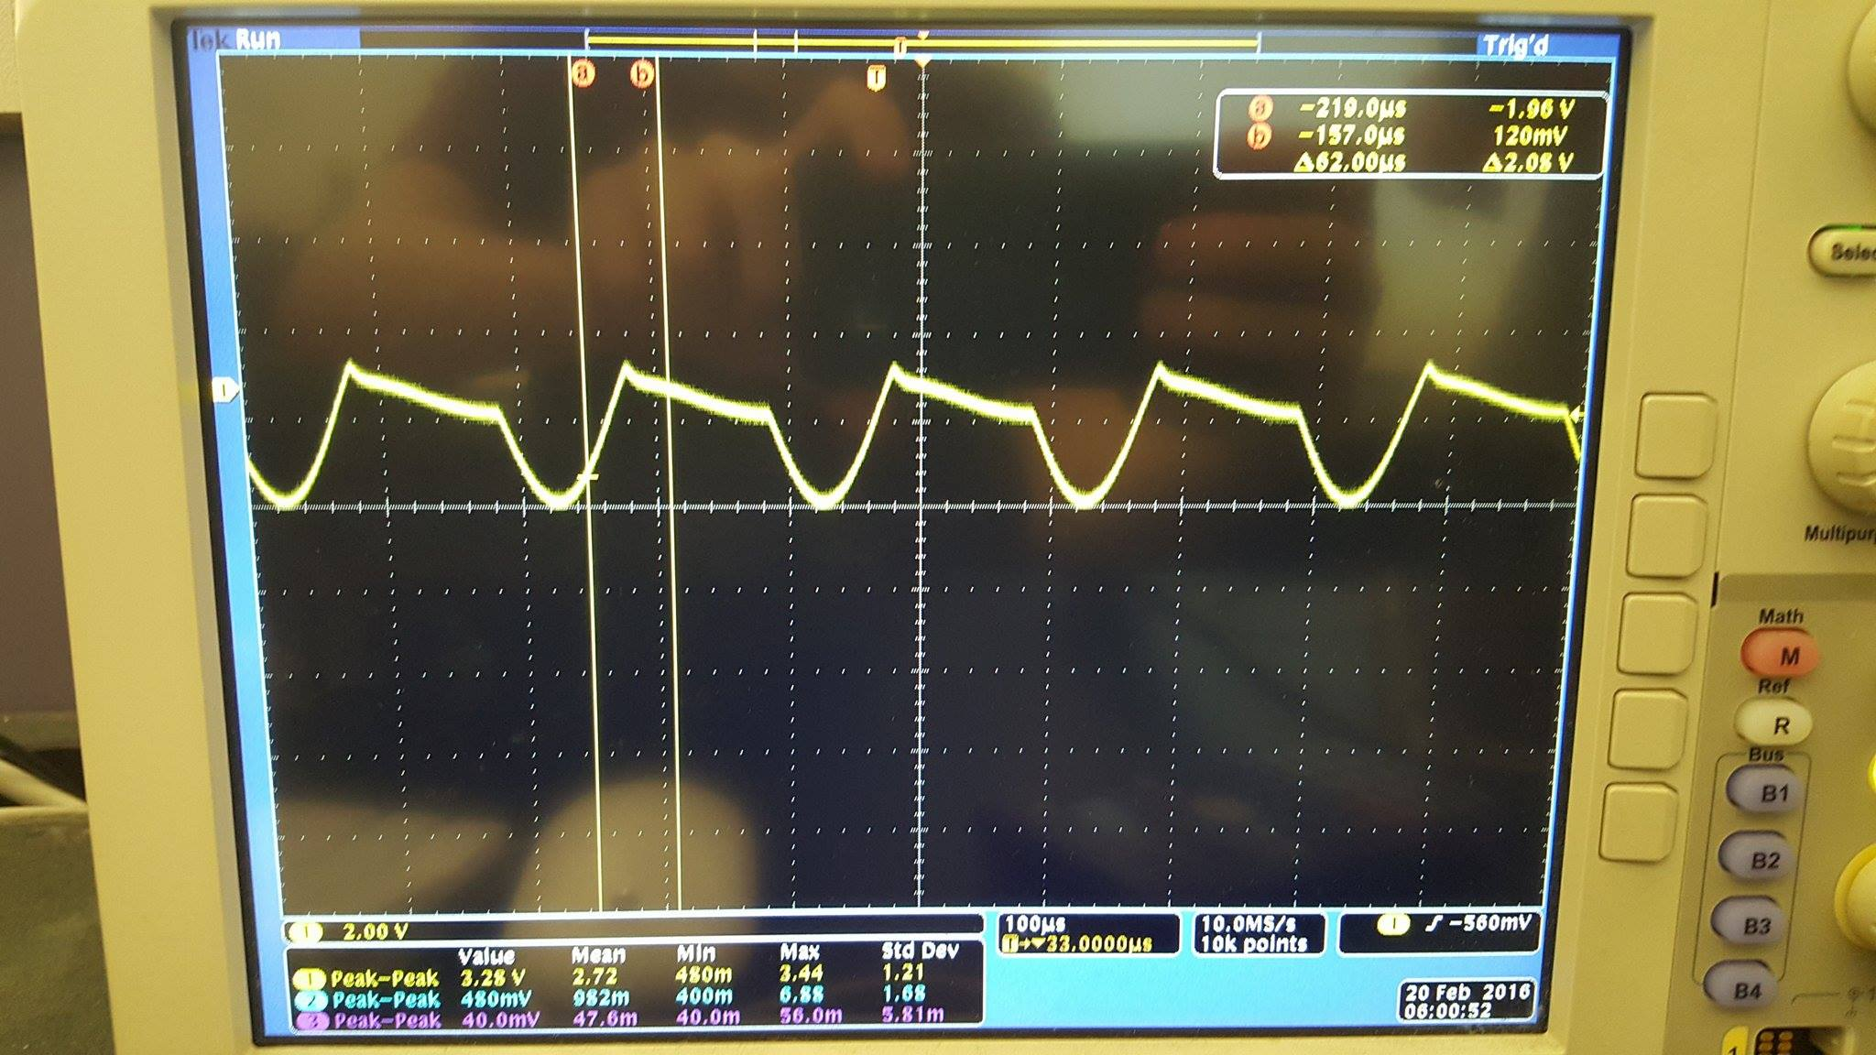

Voltage across Resistor for Circuit C

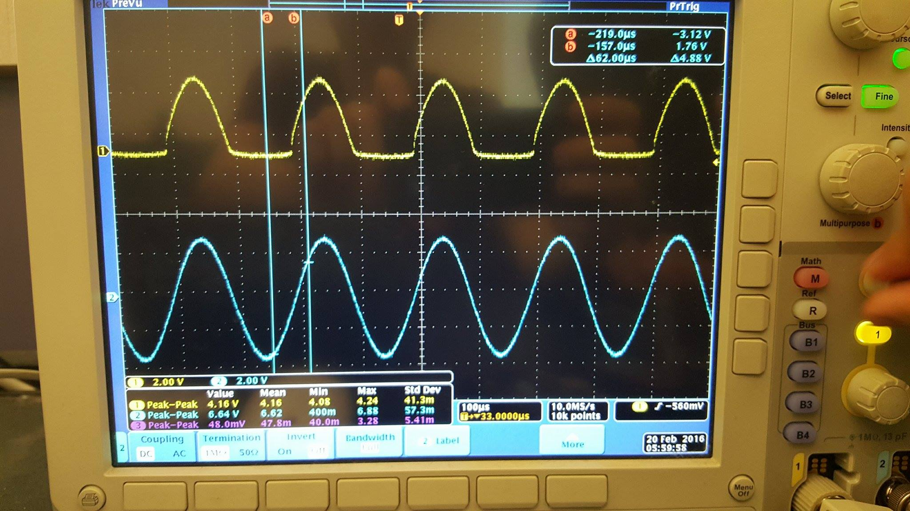

Voltage Input and Voltage Output for Circuit C

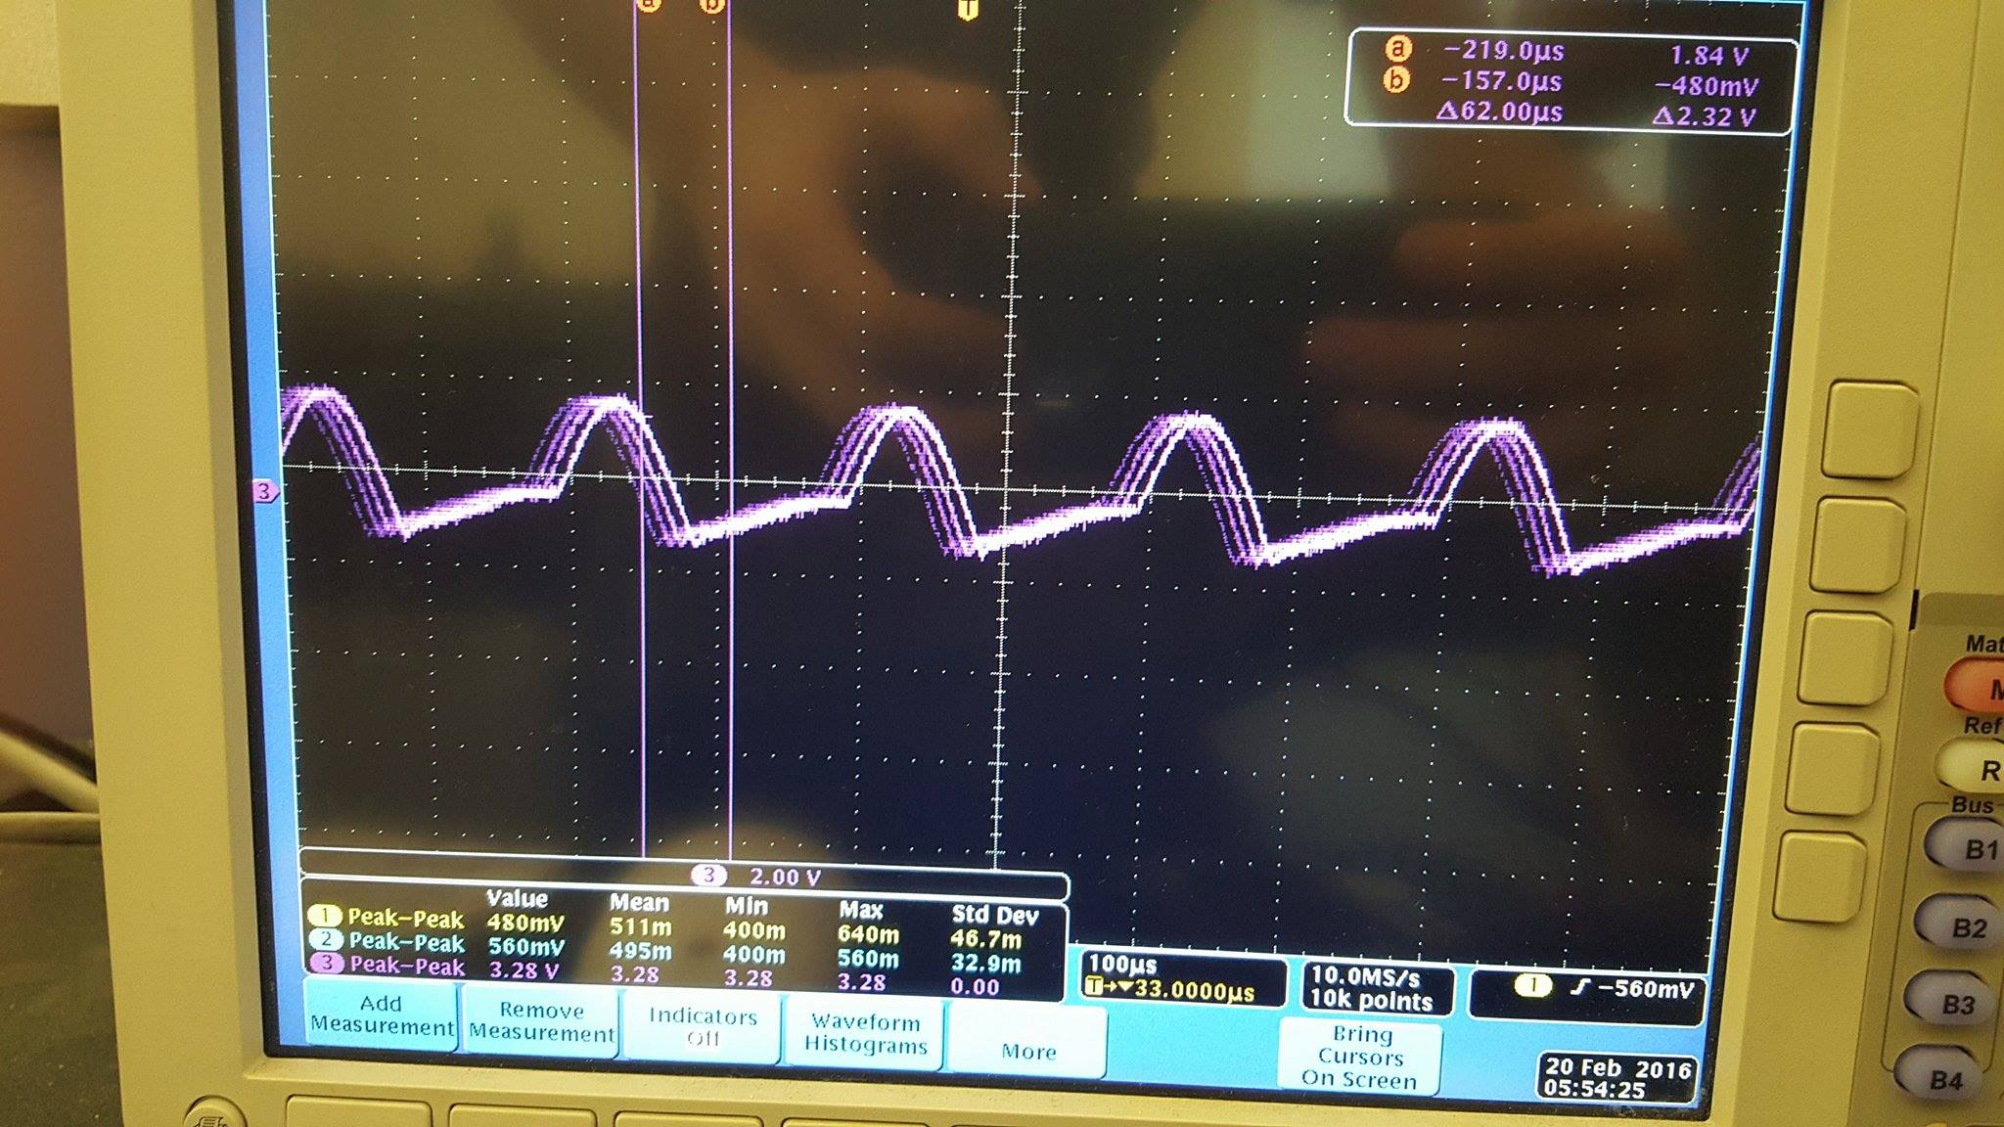

Voltage across Resistor for Circuit D

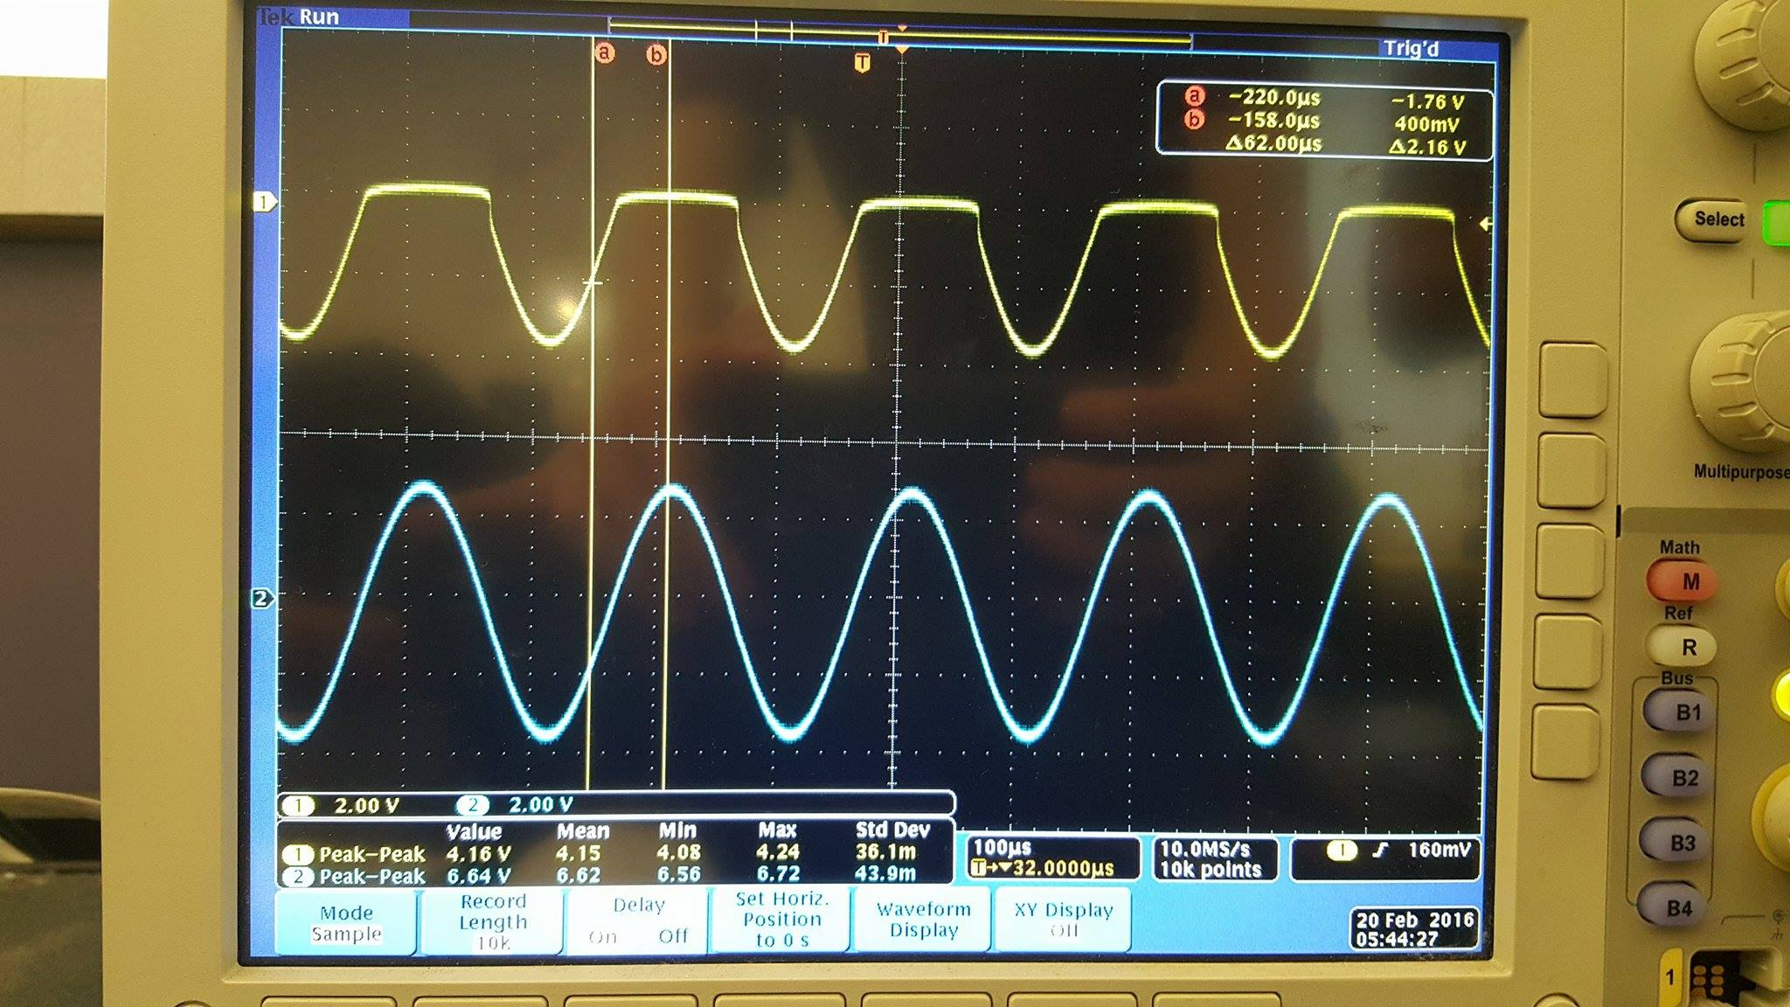

Voltage Input and Voltage Output for Circuit D

**Questions**

The experimental results are similar to my predictions in the pre-laboratory section. As seen in the Data section, the diode is in forward bias when Vs is positive and reverse bias when Vs is negative. The diode is in reverse bias when Vs is positive and forward bias when Vs is negative. In addition, the diode is in reverse bias when Vs is less than -2 V and it is in forward bias when Vs is greater than -2V. Finally, the diode is in reverse bias when Vs is greater than 2 V and it is in forward bias when Vs is greater than 2 V.

**Discussion**

The results from the laboratory experiments match with the pre-laboratory results from the hand calculations. Therefore, the hand calculations and predictions were done correctly.

**Conclusion**

The results clearly agree with the objective of the lab that is to learn how diodes function and how forward and reverse bias conditions affect the behavior of the diode, diode voltage, and current through the circuit. In addition, we use HSpice and WaveView Analyzer to corroborate our hand calculations and our measured values.